NEO Water Smart Sensor

FEATURES:
- Beeps and send alert when a leak is detected
- Control through APP

DAIS:
Device:
{
"_id": "100035e0",
"deviceTypeId": "ezlopi",
"parentDeviceId": "",
"category": "security_sensor",
"subcategory": "leak",
"gatewayId": "457a5069",
"batteryPowered": false,
"name": "Neo Water",
"serviceNotification": false,
"type": "sensor",
"reachable": true,
"roomId": "",
"security": "no",
"ready": true,
"status": "idle"
}

{
"_id": "100035e0",
"deviceTypeId": "ezlopi",
"parentDeviceId": "",
"category": "temperature",
"subcategory": "",
"gatewayId": "457a5069",
"batteryPowered": false,
"name": "Neo Water",
"serviceNotification": false,
"type": "sensor",
"reachable": true,
"roomId": "",
"security": "no",
"ready": true,
"status": "idle"
}

Items:
{
"_id": "200035f6",
"deviceId": "100035f0",
"hasGetter": true,
"hasSetter": false,
"enum": [
"no_water_leak",
"water_leak_detected",
"unknown"
],
"name": "water_leak_alarm",
"valueType": "token",
"value": "no_water_leak",
"valueFormatted": "no_water_leak"
}

{
"_id": "200035f6",
"deviceId": "100035f0",
"hasGetter": true,
"hasSetter": false,
"name": "temp",
"valueType": "temperature",
"value": 27.5,
"valueFormatted": 27.5
}

{
"_id": "200035f6",
"deviceId": "100035f0",
"hasGetter": true,
"hasSetter": false,
"name": "humidity",
"valueType": "humidity",
"value": 37.5,
"valueFormatted": 37.5
}

PICTURES:
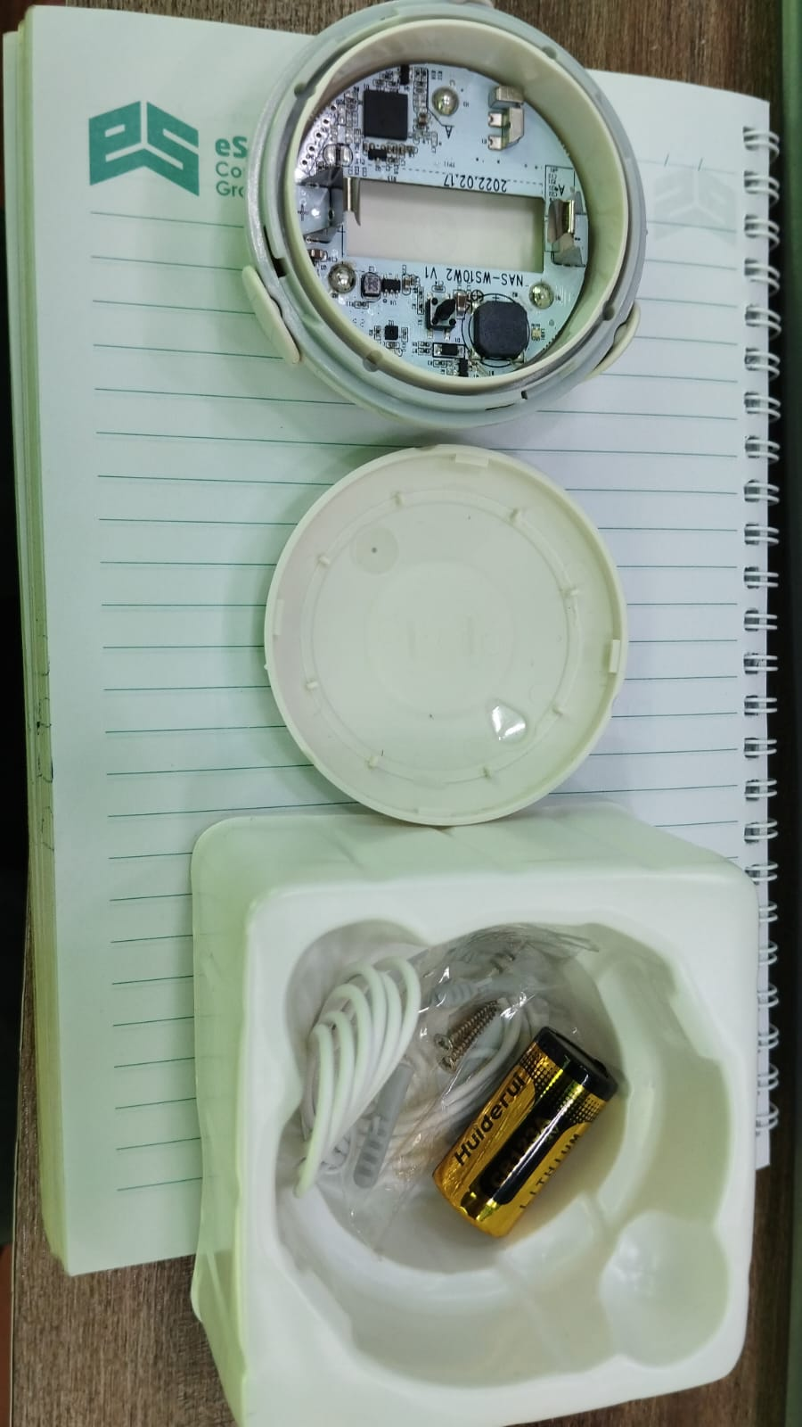
Device Inside View
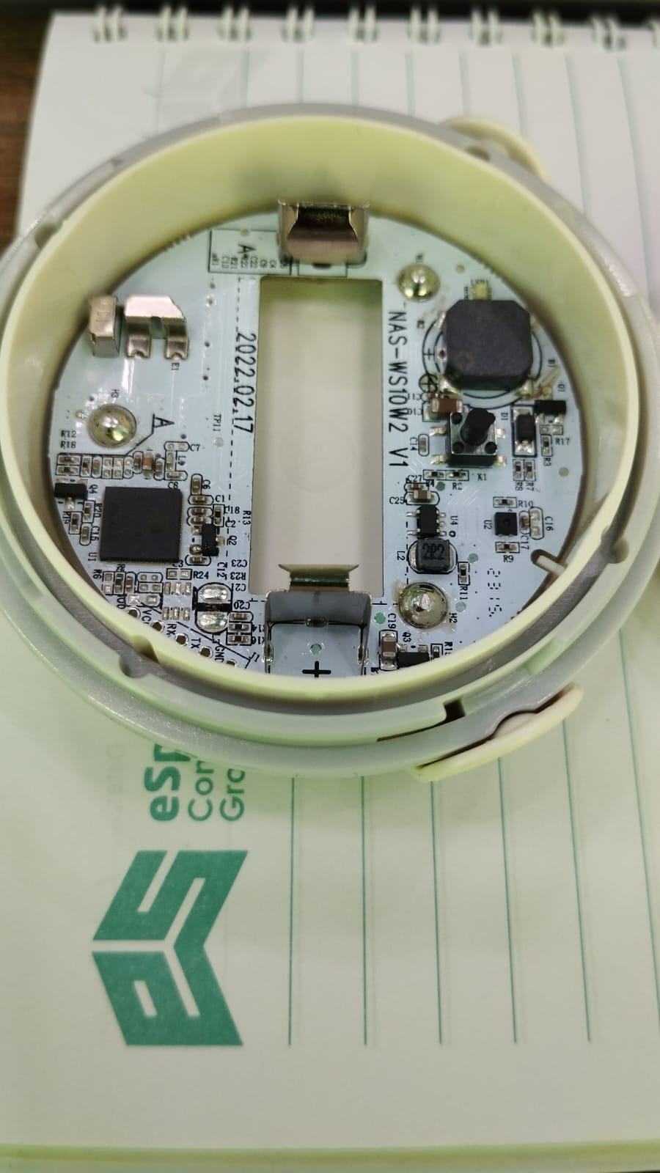
Device PCB
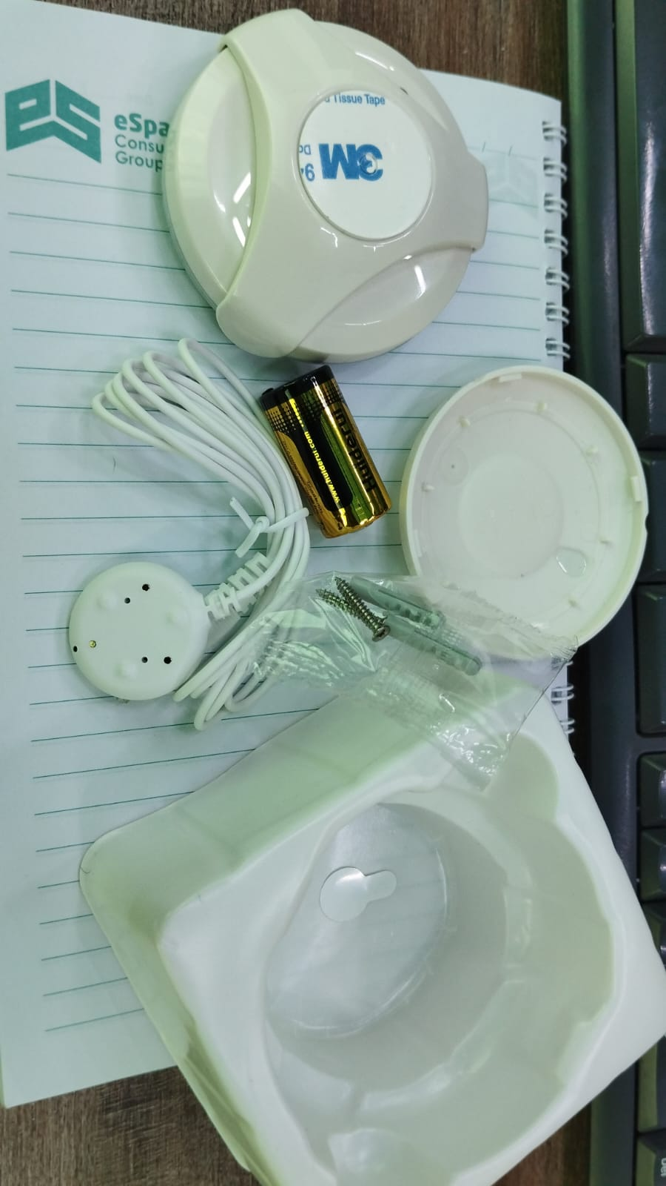
Device Outside View
SCHEMATIC:
